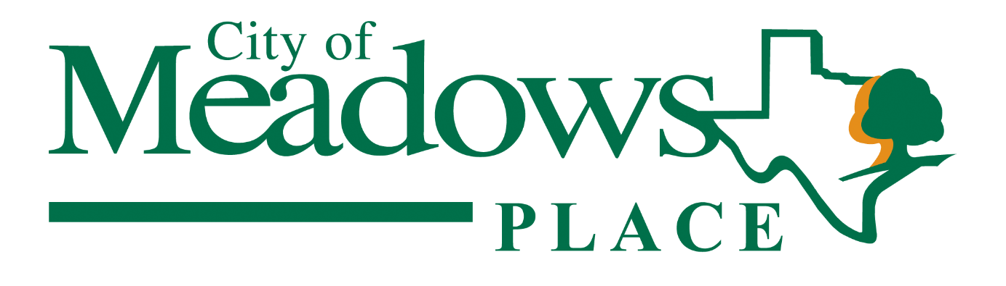

Budget and Financial Report
For the Quarter Ended 6/30/2026

Presented to City Council July 28, 2026
Prepared by Anna-Maria Weston
City of Meadows Place

Budget and Financial Report for the Quarter Ended 6/30/2026

Fiscal Year 2025-2026 is 75% complete

Overview
The purpose of this report is to assist City Council in monitoring its revenues, expenditures against budget. The report includes tables and figures showing quarterly and year to date activity. Table 1, on page 4, is a summary of all banking activity taken from monthly financial statements for quarter ending June 30, 2026. Figures 1, 2, 3 and 4, (pages 5 – 8) show fiscal year to date revenues and departmental expenditures as percent of budget for City Operations and Utility. Finally Tables 2, 3, and 4 (pages 9 – 12) are summaries of year to date revenue and expenditures in dollars compared to budget for City Operations, Utility and EDC. The revenues and expenditures are through the end of June 2026 which represents 75% completion of the budget year.
This report contains the most accurate and up-to-date information at date of publication. It may not include all expenditures that were incurred during the quarter due to invoices not yet received or paid.
Table of Contents Page(s)
Summary of Activity for Fiscal Year 2 - 3
Figure 1. City Revenues (% of Budget) through 6/30/2026 4
Figure 2. City Expenditures (% of Budget) through 6/30/2026 5
Figure 3. Utility Revenues (% of Budget) through 6/30/2026 6
Figure 4. Utility Expenditures (% of Budget) through 6/30/2026 7
Table 1. City General Operations Revenue and Expenditures vs Budget ($) 8-10
Table 2. Utility Revenue and Expenditures vs Budget ($) 11-12
Table 3. EDC Revenues and Expenditures vs Budget ($) 13
Summary of Activity

City Revenues
General Fund revenues reached 90.9% of budget at the end of the quarter, slightly below last year’s 91.2%.
Property tax collection at end of the second quarter was at 98.6% of budget or $4,551,077. Property taxes account for approximately two-thirds of the City’s budget.
Sales tax, permits and interest revenue are below the 75% budget and will continue to be monitored, but the expectation is that these revenues will fall below budget for the year.
Fines and Forfeitures revenue are performing above expectations at 88.4% of budget, or $437,762 of a $495,000 budget.
Park programs and activities have exceeded the annual budget and are at 103% of budget, a result of pool pass sales.
The catalytic converter funding from last fiscal year of $40,000 remains outstanding.

City Expenditures
All departments are at or below 75% of budget, except for Public Works operations, which is 81.7%. Public Works is above due to several accounts being at budget for the year, including fire protection services, street and sidewalk repair. Personnel and benefits expenditures remain below budget across all departments. The Police Department, the City’s department with most staff, is at 67% of budget.
Overall, total City expenditure is 71.6% of budget.
City Capital Projects
During the quarter, the City made payments of $90,500 to Sander’s Engineering for design work on the Dorrance phase 3 project through May. The design is at 40% of completion.
City Fund Transfers
During the quarter, $2,000,000 was transferred from TexPool regular to TexPool Prime account to earn additional interest.

Utility Revenues
Utility revenues are generally in line with expectations, with most categories at or near 75% of budget. Interest income is higher than anticipated at 112%. Overall, Utility revenues stand at 79.9% of budget.

Utility Expenditures
Most expenditures are below 75% of budget, with the exception sludge hauling, which is at 342% of budget. Year-to-date sludge hauling costs total $116,895 compared with a $20,000 budget, because of early fiscal year biosolids removal. Overall Utility expenditures are at 71.4%.

Utility Fund Transfers
During the quarter, $100,000 was transferred from South State Utility checking account to Lonestar Utility Operations account to earn additional interest.

EDC Revenues and Expenditures
EDC revenues are in line with budget, with interest reaching 135% of budget.
EDC expenses are at 69.7% of budget, largely due to the $280,000 transfer to the City’s Infrastructure account.

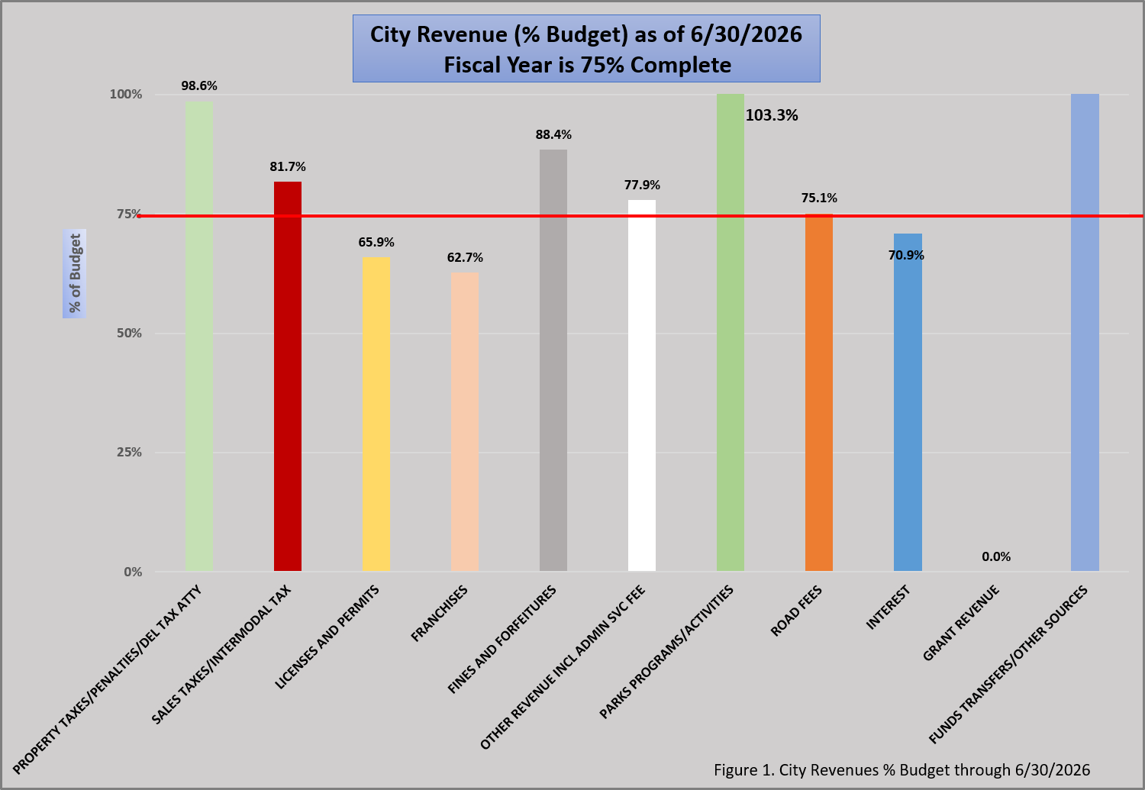
Table 1. 4th Q’2023 Banking Activity
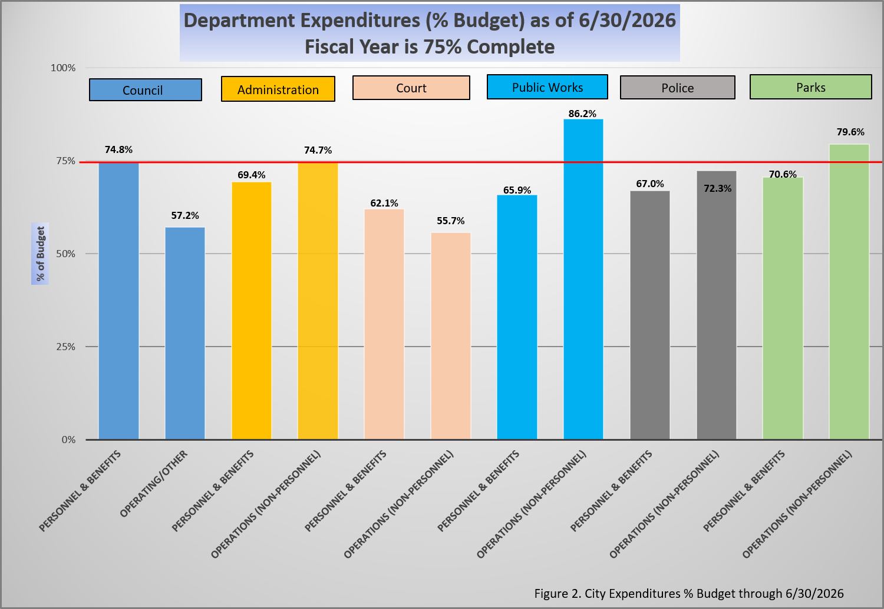
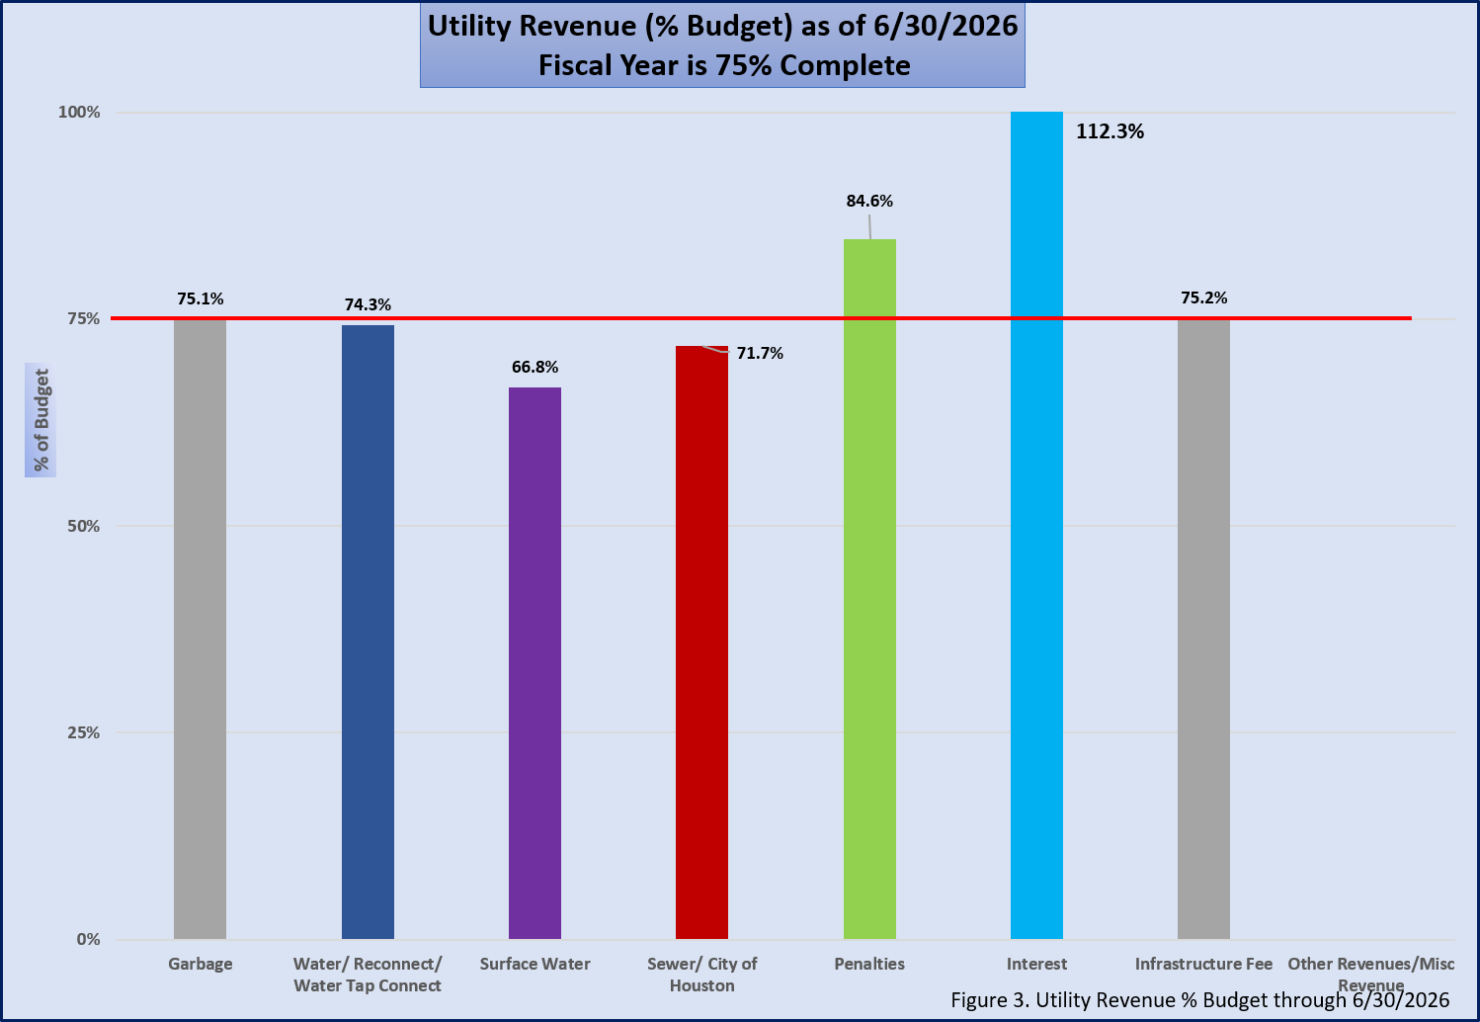
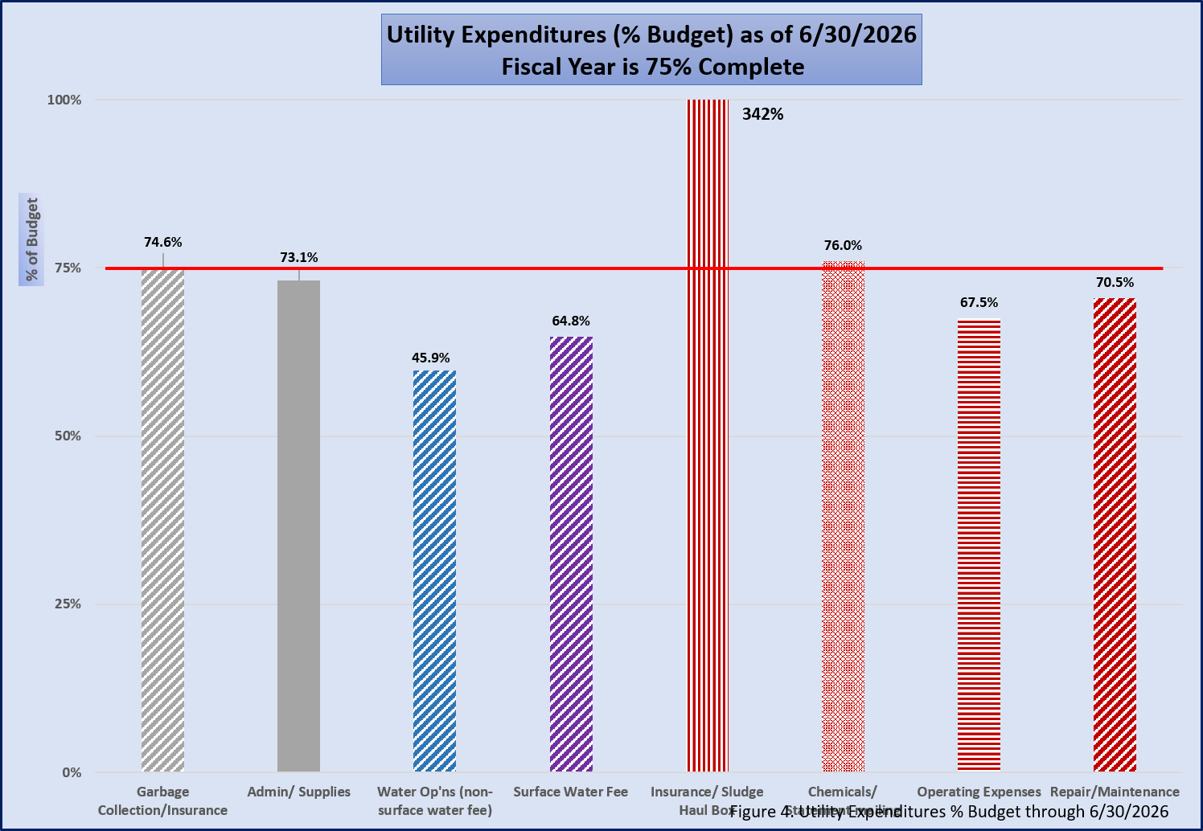
City Meadows Place
City Operations Budget Report
For the Quarter Ended 6/30/2026
Fiscal Year 2025-2026 is 75% complete

Table 1. City General Revenue vs Budget

Table 1 Cont’d.. City General Expenditures vs Budget
Table 1 Cont’d. City General Expenditures vs Budget

City Meadows Place
Utility Budget Report
For the Quarter Ended 6/30/2026
Fiscal Year 2025-2026 is 75% complete

Table 2. Utility Revenue vs Budget

Table 2. Cont’d. Utility Expenditures vs Budget

City Meadows Place
EDC Budget Report
For the Quarter Ended 6/30/2026
Fiscal Year 2025-2026 is 75% complete

Table 3. EDC Revenue and Expenditures vs Budget

